**Anaconda Installation Guide for Windows**

1. Go to the [Anaconda Website](https://www.anaconda.com/products/distribution#windows) and click the green download button. This will download the Python 3.9 graphical installer for Windows.



1. Locate your download and double click it.
2. When the screen below appears, click on Next.

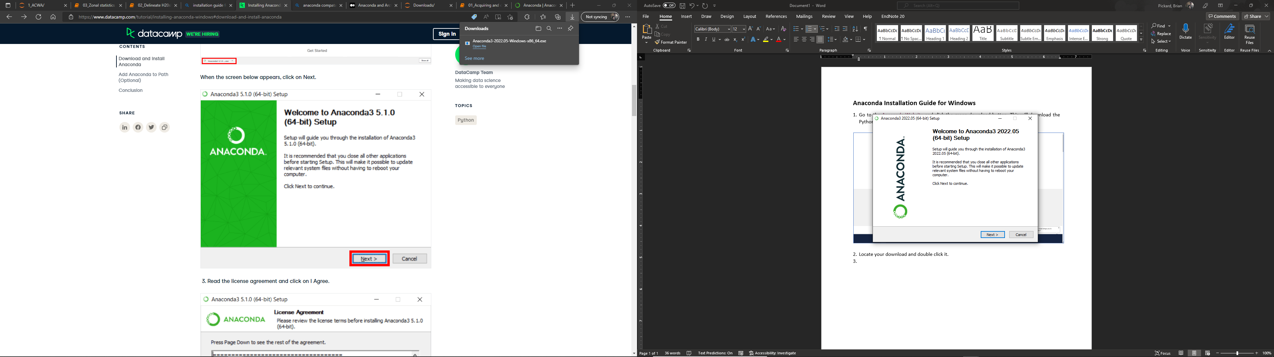

1. Read the licensing agreement and click on I agree.

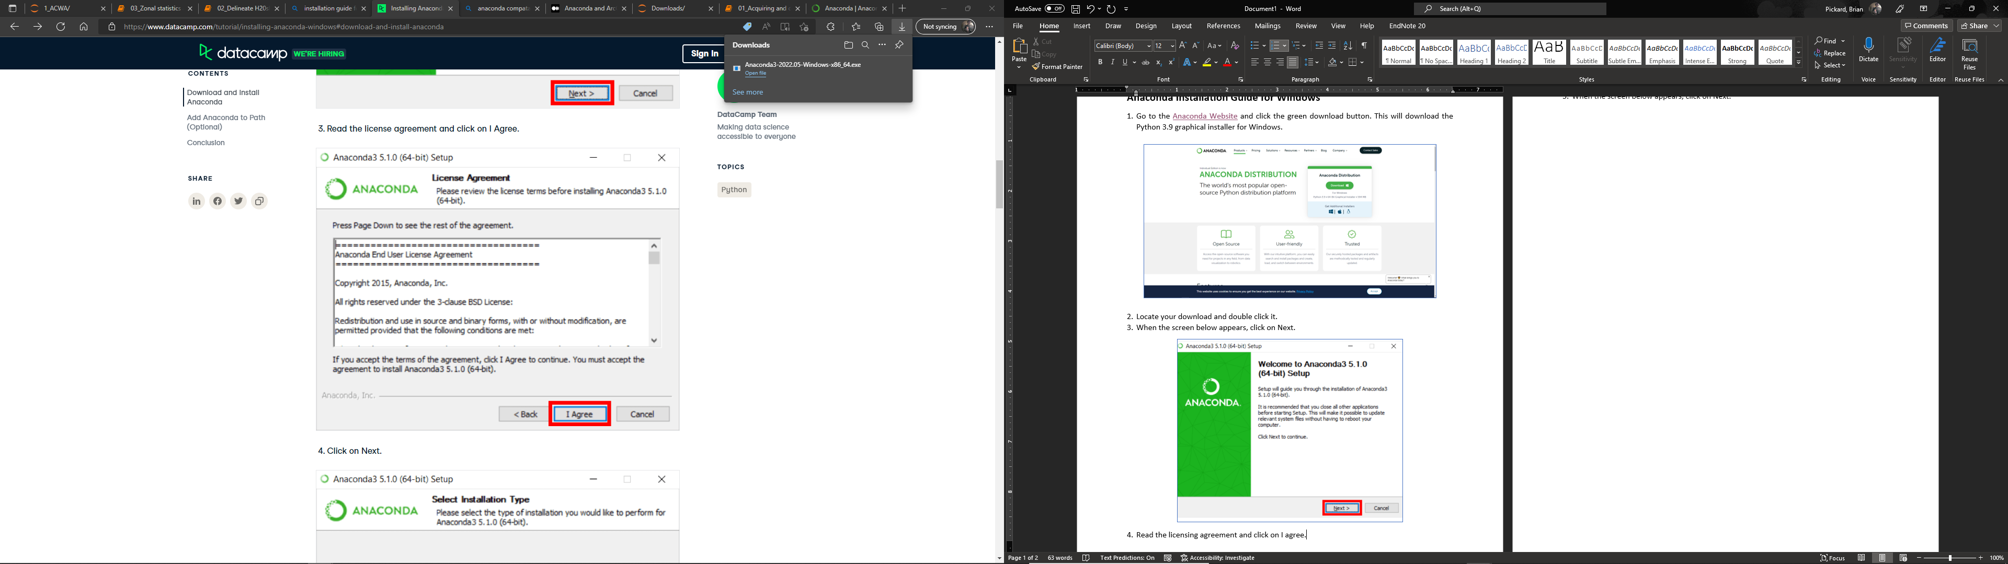

1. Click on Next to install for “Just Me”.

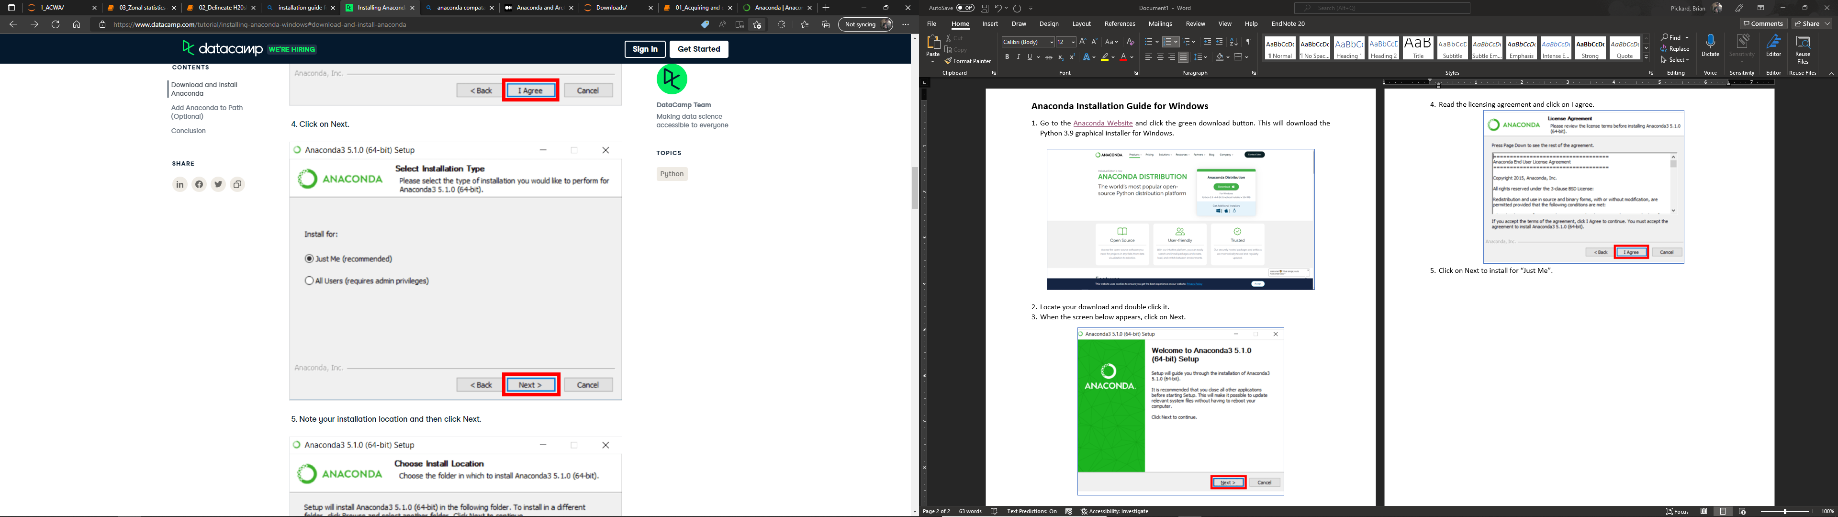

1. Note your installation location and click Next.

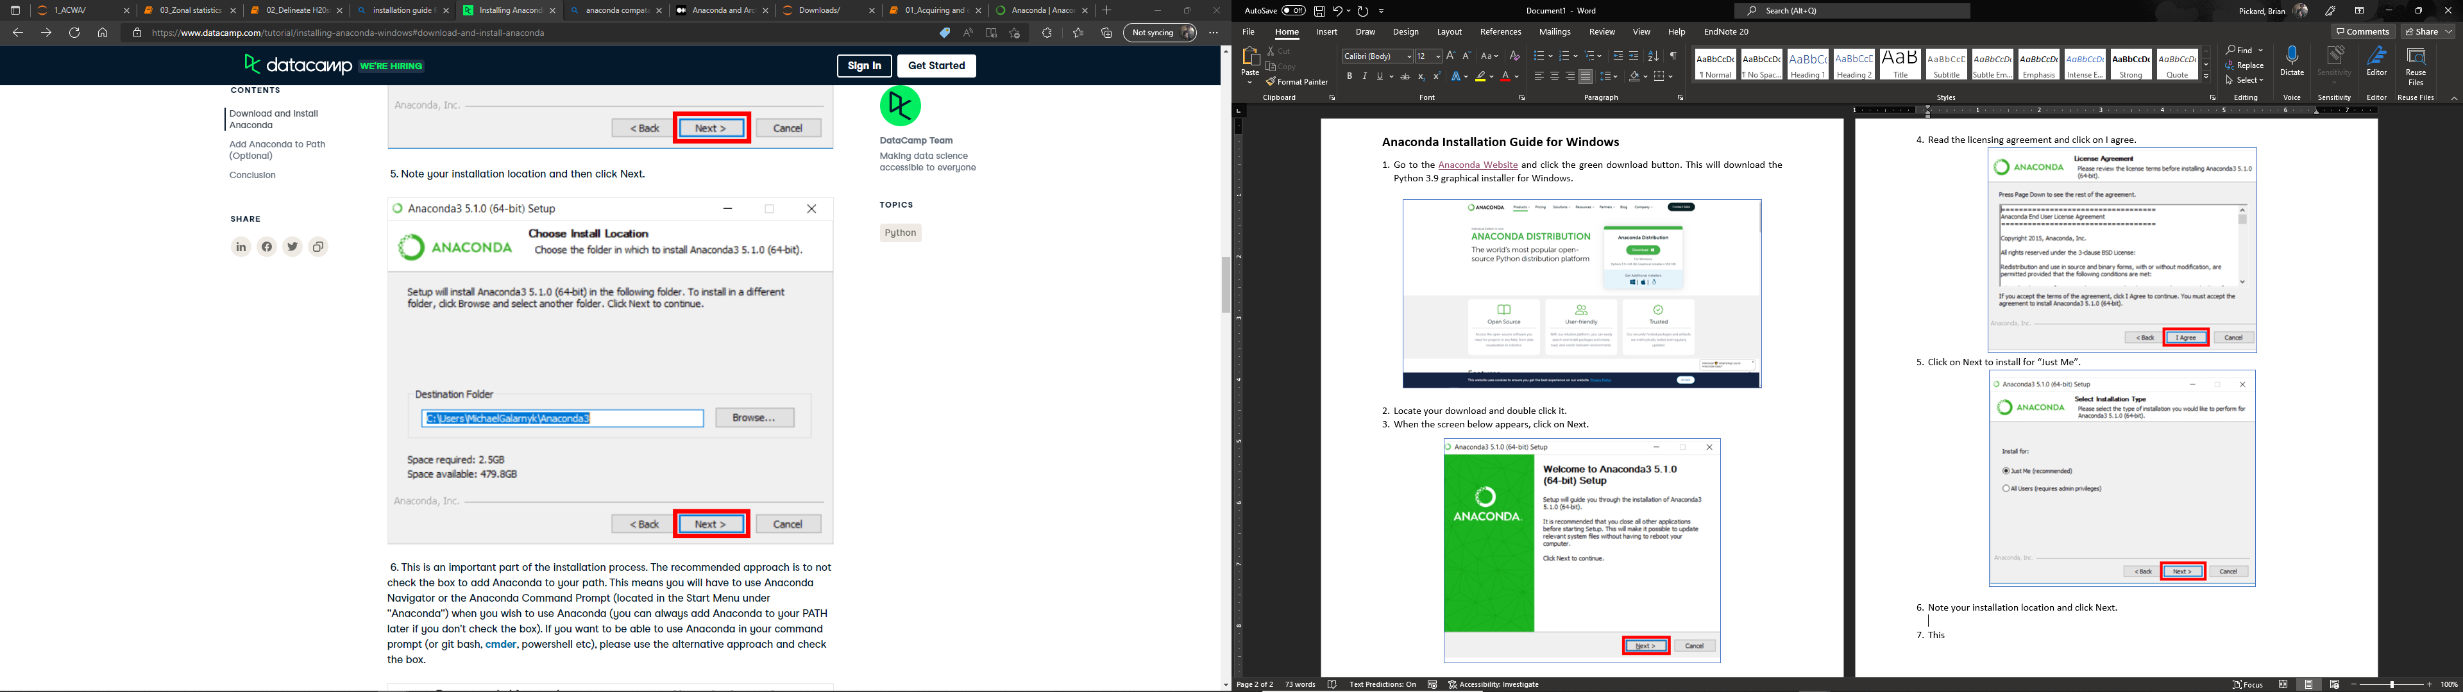

1. This is the important part of the installation process. The recommended approach is to not check the box to add Anaconda to your PATH. This means you will have to use Anaconda Navigator or the Anaconda Command Prompt (located in the Start Menu under “Anaconda”) when you wish to use Anaconda (you can always add Anaconda to your PATH later if you don’t check the box).

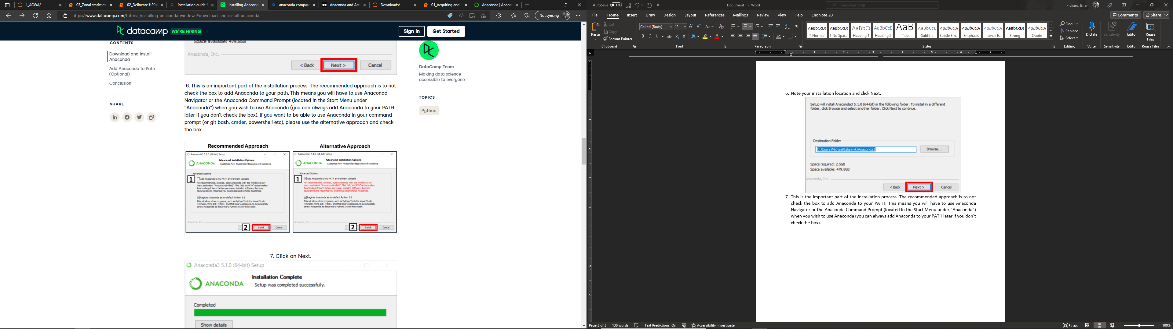

1. Click on Next.

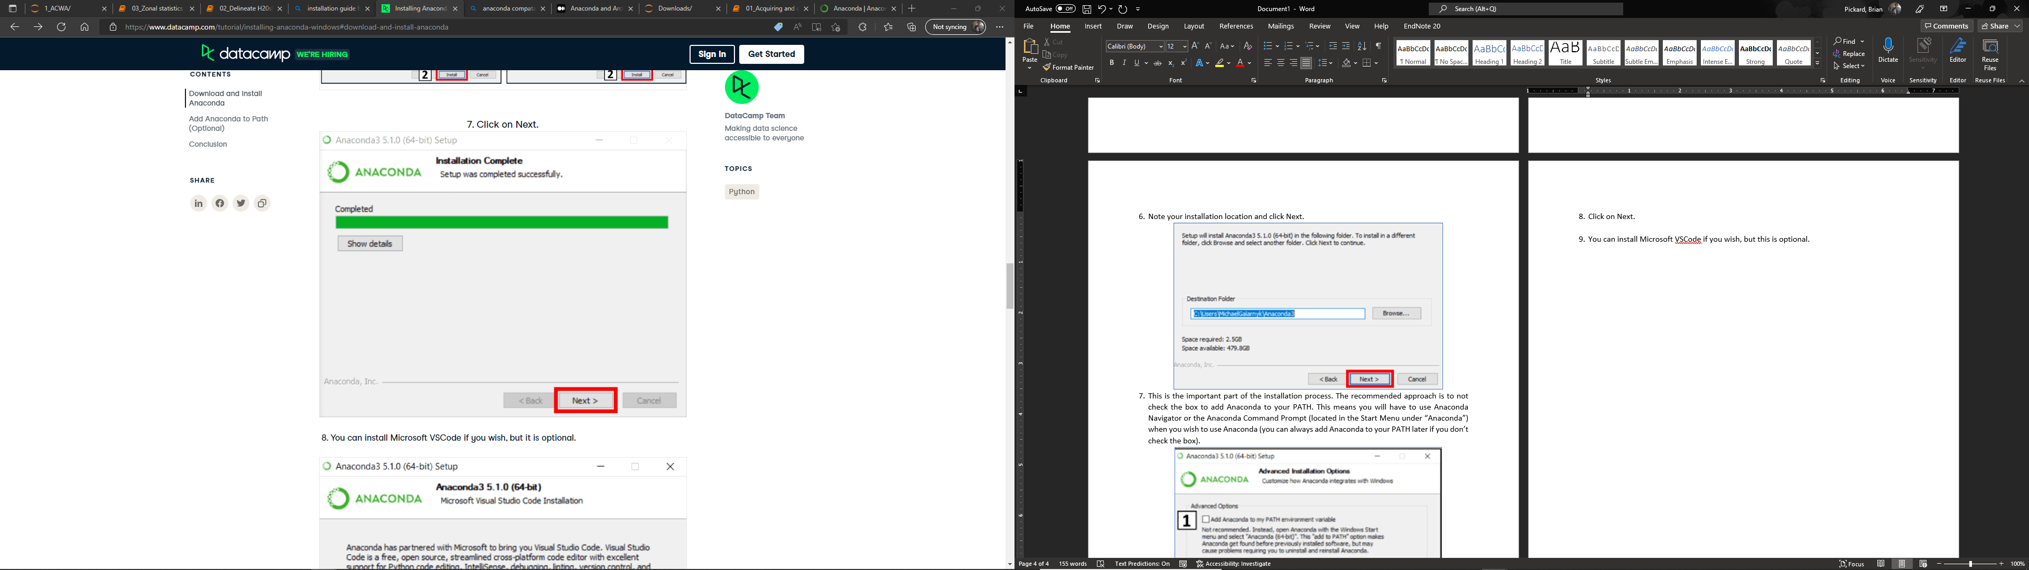

1. You can install Microsoft VSCode if you wish, but this is optional.

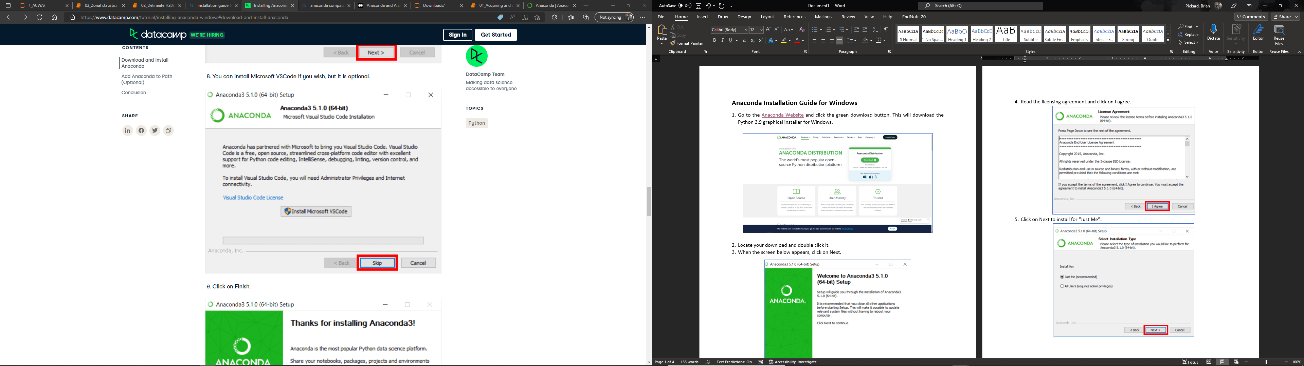

1. Click on Finish.

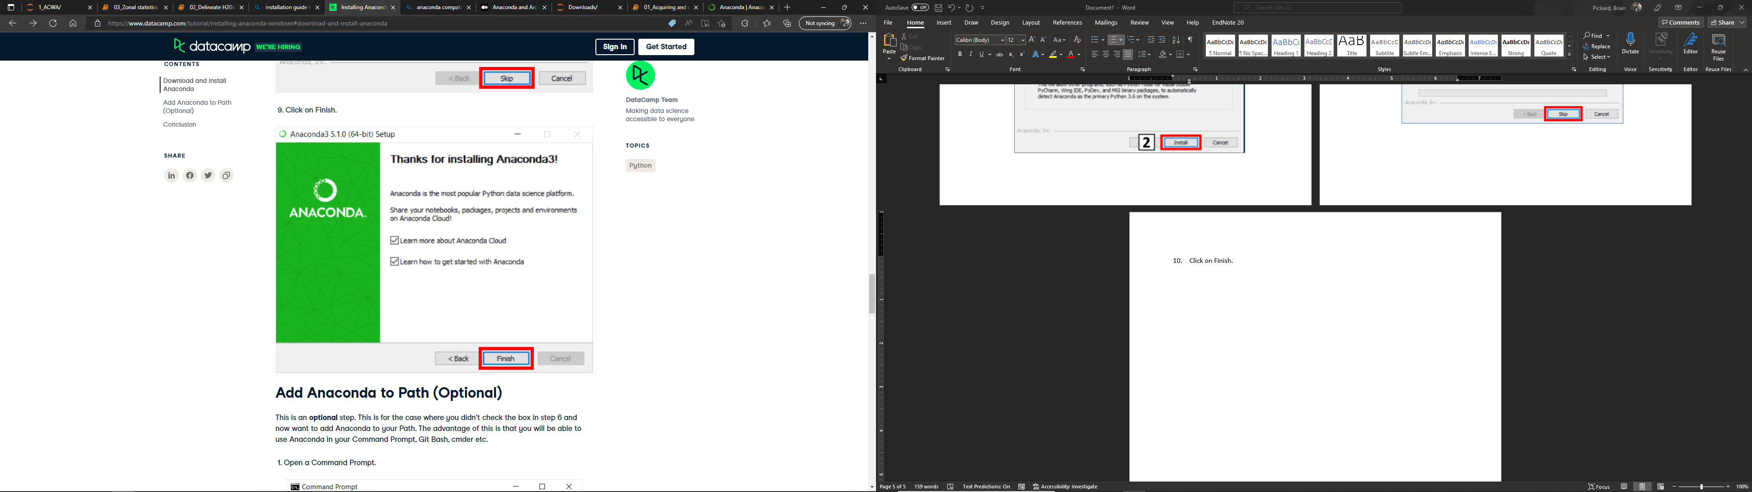

**Installing Jupyter notebook from Anaconda Navigator**

1. Open Anaconda Navigator from your start menu.

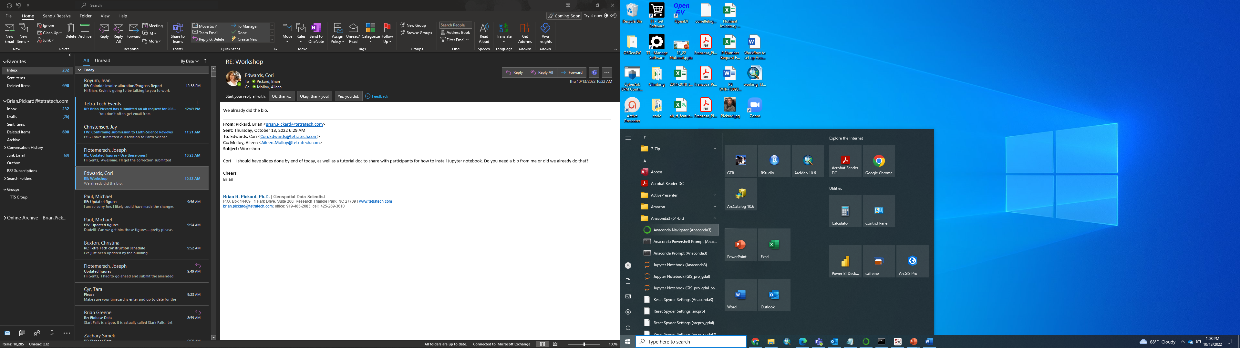

1. Once Anaconda Navigator opens, click on the Environments tab.

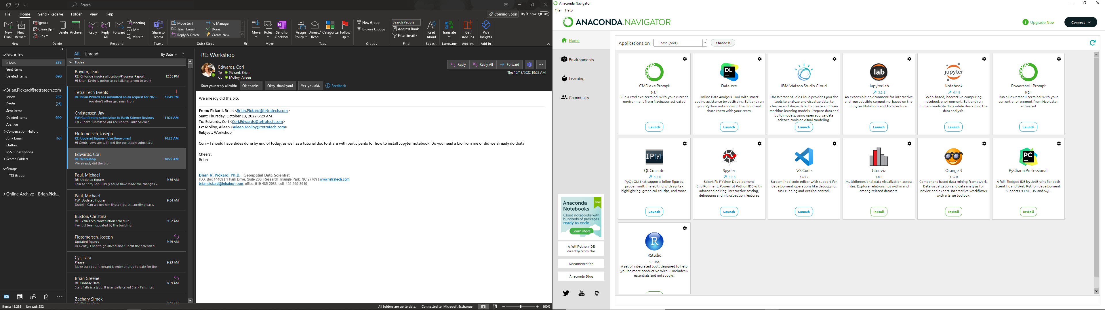

1. Click create new environment.

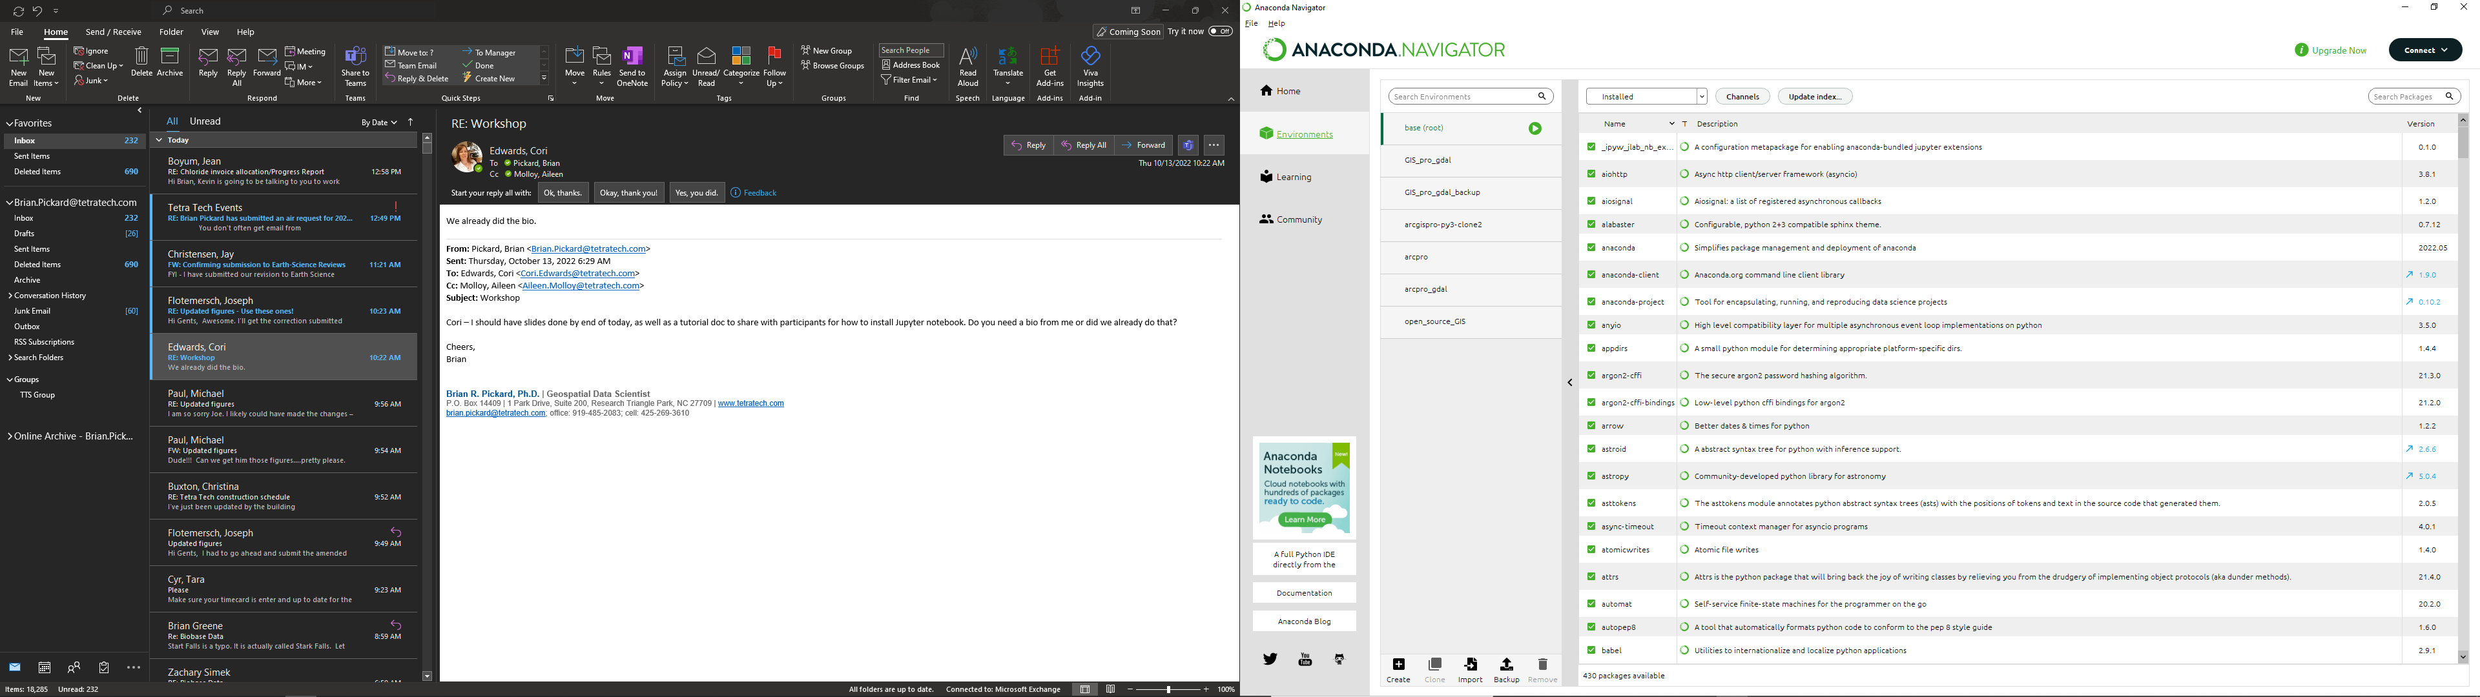

1. Specify a name and a Python version. If you don’t need a specific Python version for a particular project, use the default. Then click Create.

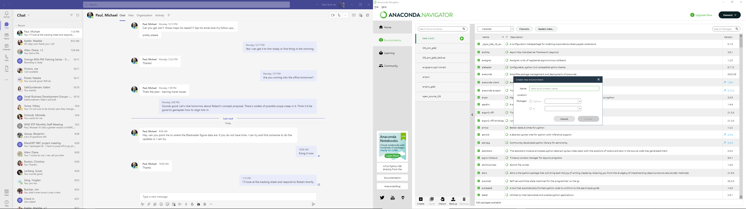

1. Return to the home section by clicking on Home in the left-hand navigation bar. On the home screen click the Install button for the Jupyter Notebook.

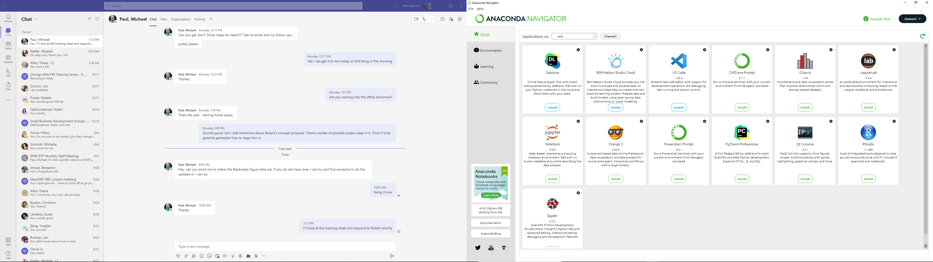

1. Once installed, open the Jupyter Notebook by clicking on Launch.